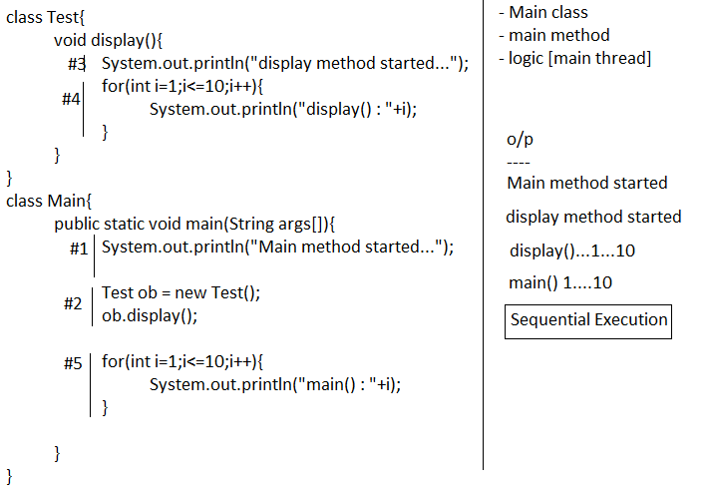
Multithreading
- Executing different parts of the program simultaneously is called multithreading.
- Thread is the separate path of sequential execution.
- The main advantage of multithreading is to improve the CPU utilization. Hence execution speed will be increased and response time will be decreased.
Main Thread
- When a java program started one thread is running immediately that thread is called main thread.
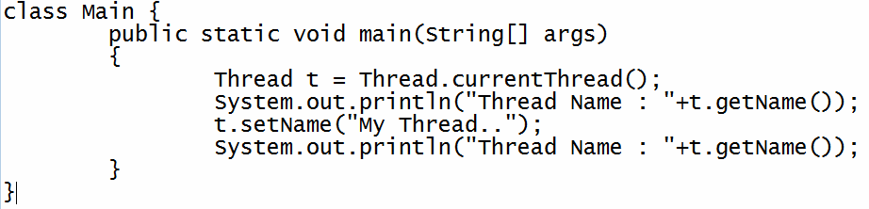

Different ways to create thread
- By extending Thread class
- By implementing Runnable interface
Internal of Thread Class and Runnable Interface
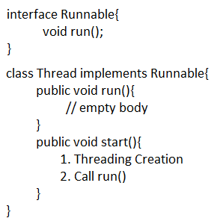
By extending Thread class
- Create a class by extending Thread class.
- Override the run() method to write the logic of the thread
- Create user defined thread class object
- Start thread by calling start() method of Thread class

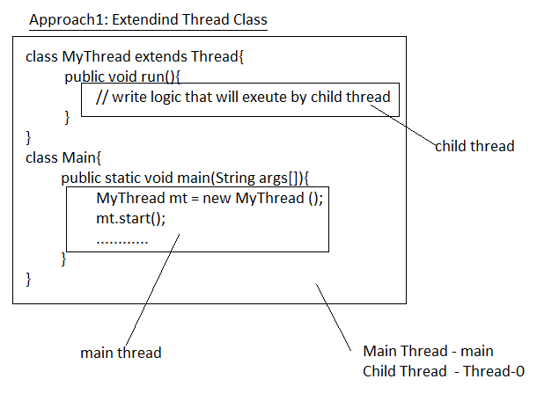
Example
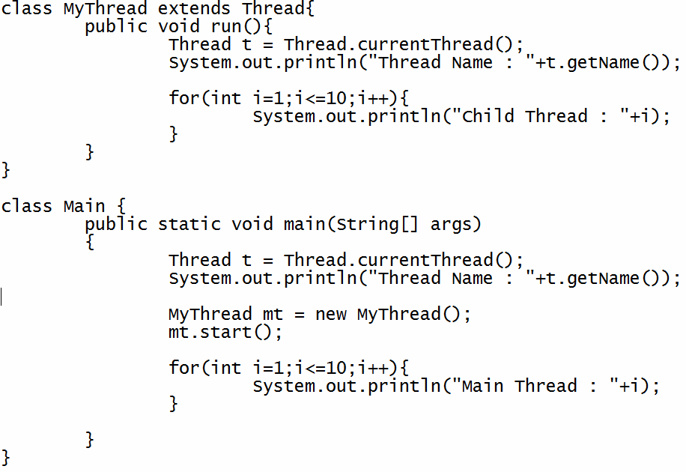
By implementing Runnable Interface
- Create a class by implementing Runnable interface.
- Override the run() method to write the logic of the thread
- Create user defined thread class object
- Creates a Thread class object
- Start thread by calling start() method of Thread class

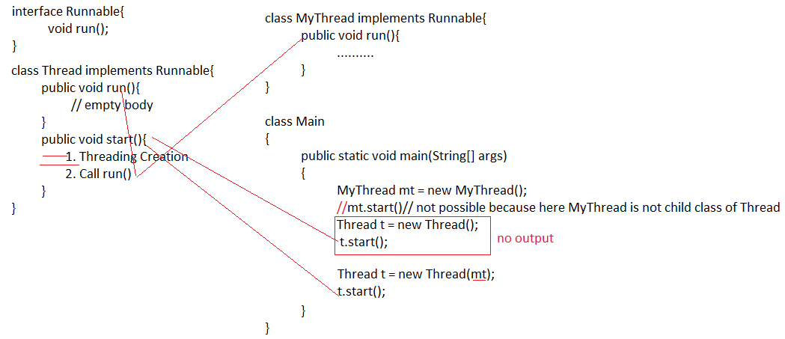
Example
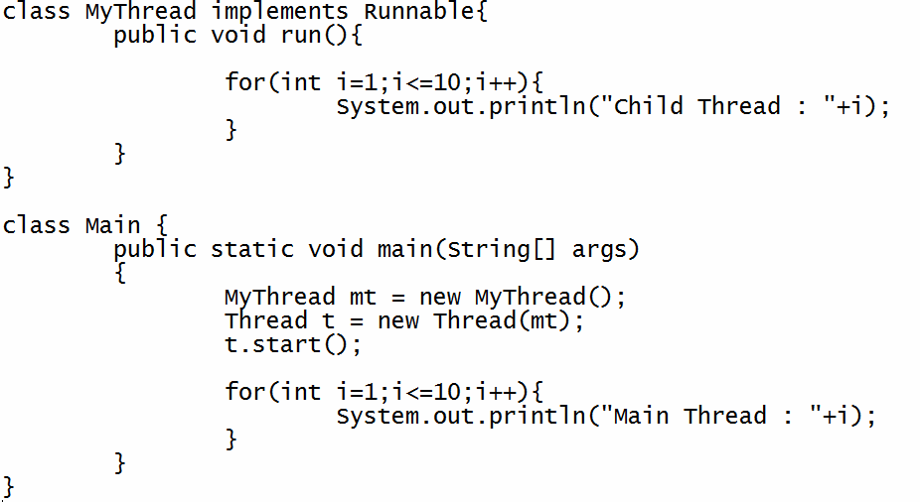
Thread Priorities
- The valid range of thread priorities is 1 – 10. Where one is lowest priority and 10 is highest priority.
- The default priority of main thread is 5. The priority of child thread is inherited from the parent.
- Three constant values for the thread priority.
MIN_PRIORITY = 1
NORM_PRIORITY = 5
MAX_PRIORITY = 10
Example
class MyThread extends Thread
{

public void run()

{

Thread t = Thread.currentThread();
System.out.println("Child Thread : "+t.getPriority());
}

}
class Main{

public static void main(String arg[])

{
Thread t = Thread.currentThread();
t.setPriority(10);
System.out.println("Main Thread : "+t.getPriority());

MyThread mt = new MyThread();
mt.setPriority(5);

mt.start();

}

}

